EXPERIMENT 6
CREATE TABLE ITEMS_49A(ITEM_ID INT PRIMARY KEY,ITEM_NAME VARCHAR(50),CATEGORY VARCHAR(50),PRICE INT,INSTOCK INT CHECK (INSTOCK >= 0));
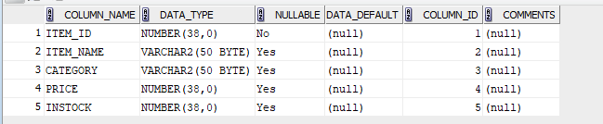
CREATE TABLE CUSTOMERS(CUST_ID INT PRIMARY KEY,CUST_NAME VARCHAR(50),ADDRESS VARCHAR(50),STATE VARCHAR(50));
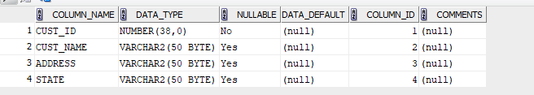
CREATE TABLE ORDERS_49A(ORDER_ID INT PRIMARY KEY,ITEM_ID INT,CUST_ID INT,QUANTITY INT,ORDER_DATE DATE,FOREIGN KEY (ITEM_ID)REFERENCES ITEMS_49A (ITEM_ID),FOREIGN KEY (CUST_ID)REFERENCES CUSTOMERS(CUST_ID));
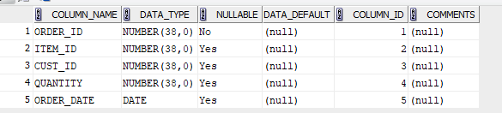
CREATE TABLE DELIVERY_49A(DELIVERY_ID INT PRIMARY KEY,CUST_ID INT,ORDER_ID INT,FOREIGN KEY (CUST_ID)REFERENCES CUSTOMERS(CUST_ID),FOREIGN KEY (ORDER_ID)REFERENCES ORDERS_49A(ORDER_ID),STATUS VARCHAR(50));
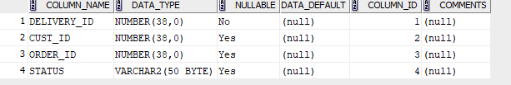
- SELECT * FROM CUSTOMERS WHERE CUST_ID IN ( SELECT CUST_ID FROM ORDERS_49A);
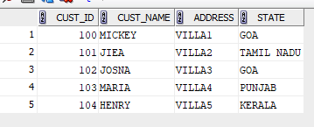
- SELECT DISTINCT c.* FROM CUSTOMERS c JOIN ORDERS_49A o ON c.CUST_ID = o.CUST_ID JOIN DELIVERY_49A d ON o.ORDER_ID = d.ORDER_ID WHERE d.STATUS = 'DELIVERED';
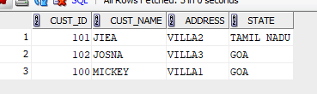
- SELECT C.CUST_NAME, O.ORDER_DATE FROM CUSTOMERS C JOIN ORDERS_49A O ON C.CUST_ID = O.CUST_ID WHERE C.CUST_NAME LIKE 'J%';
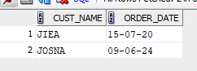
- SELECT I.ITEM_NAME, I.PRICE FROM CUSTOMERS C JOIN ORDERS_49A O ON C.CUST_ID = O.CUST_ID JOIN ITEMS_49A I ON O.ITEM_ID = I.ITEM_ID WHERE C.CUST_NAME = 'MICKEY';
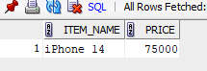
- SELECT DISTINCT C.* FROM CUSTOMERS C JOIN ORDERS_49A O ON C.CUST_ID = O.CUST_ID JOIN DELIVERY_49A D ON O.ORDER_ID = D.ORDER_ID WHERE O.ORDER_DATE > '31-01-2013' AND D.STATUS <> 'DELIVERED';
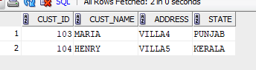
- SELECT DISTINCT ITEM_ID FROM ORDERS_49A
UNION
SELECT DISTINCT O.ITEM_ID FROM ORDERS_49A O JOIN DELIVERY_49A D ON O.ORDER_ID = D.ORDER_ID WHERE D.STATUS <> 'DELIVERED';
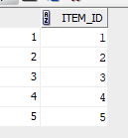
- SELECT DISTINCT C.CUST_NAME FROM CUSTOMERS C JOIN DELIVERY_49A D ON C.CUST_ID = D.CUST_ID WHERE D.STATUS = 'DELIVERED';
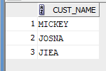
- SELECT CUST_NAME FROM CUSTOMERS WHERE CUST_ID IN (SELECT CUST_ID FROM ORDERS_49A)
MINUS
SELECT C.CUST_NAME FROM CUSTOMERS C
JOIN DELIVERY_49A D ON C.CUST_ID = D.CUST_ID
WHERE D.STATUS = 'DELIVERED';
